# Data Modification Language

## Step 1: Insert rows into table

Syntax

-- let there be N columns in a table

INSERT INTO <tableName>

values

(Column1Value,Column2Value, Column3Value,….,ColumnNValue), --row 1

(Column1Value,Column2Value, Column3Value,….,ColumnNValue), --row2

(Column1Value,Column2Value, Column3Value,….,ColumnNValue) –row 3

Or

INSERT INTO <tableName> (ColumnX,ColumnY) -- List of Columns

values

(ColumnXValue,ColumnYValue), --Row 1 list of Corrrespong column values

(ColumnXValue,ColumnYValue), --Row 2

(ColumnXValue,ColumnYValue) –Row 3

Try the following



Try the following



## Step 2: To see the data from you table use the following table

Select * from tableName

Try the following and see the results

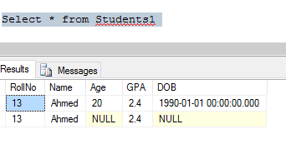

## Step 3: Delete rows from the table

Delete from <tableName>

Where <conditions>

Try the following and see the message and data in table using select query

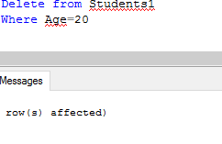

## Step 4: Delete all the data from the table

Delete from <tableName> --as there is no where condition all rows will be deleted

Or

Truncate table <tableName>

Try these two commands after adding some rows to the table and see the results.

## Step 5: Updating the rows

Update tableName

set ColumnA=<NewValue>,

ColumnB=<NewValue>,

where <Conditions>

See the data in table before and after trying the following query

